Transfer Student Center Proposal
Submitted by:
Transfer Services Team

May 2017

Executive Summary
The Office of Transfer Services (OTS) at Appalachian State University serves all prospective, admitted, and enrolled transfer students. The services offered have increased greatly in recent years to keep pace with the increasing needs of the transfer population at Appalachian. Originally developed as the Office of Transfer Articulation to evaluate credit and develop articulation agreements with partner community colleges, the office has expanded into the Office of Transfer Services and serves the needs of transfer students from prospective inquiry through to graduation. Given the divergent needs of transfer students, they are a population requiring individual attention. The location of OTS in John E Thomas Hall is ideally situated to meet with students looking for transitional advising, credit evaluation, and other transactional inquiries. However, there is not a physical space, similar to the Women’s or Veteran’s Centers, where enrolled transfer students can engage with one another. Originally proposed by the Transfer Services Team in 2013 and again in 2017, a Transfer Student Center would be centrally located on campus and support transfer students' orientation, transition, and retention to Appalachian State University by facilitating social integration and offering social and educational programming throughout their first year on campus.

Demonstrating the Need
The Transfer Services Team was established in March 2013 to identify the services and resources that should be available to transfer students at Appalachian. At the time the team recommended creating a Transfer Services Center which “should be a home for transfer students, a place where they can meet people, make friends and develop a sense of community” (Transfer Services Team Final Report, 2013). Four years later, the Transfer Services Team believes this need is even more important. In Fall 2016 Appalachian welcomed 1,266 new transfer students but only 20% of those new students lived on campus. Appalachian requires first-year students to live on campus to “develop a greater sense of belonging through the varying opportunities for involvement on Appalachian’s campus” (Residential Learning Plan, 2017). New transfer students living off campus struggle to find that sense of belonging and with 71% of new transfer students last fall coming from community colleges and living on their own for the first time we have the responsibility to teach social engagement to them the same way we approach teaching first-year students. With limited on-campus housing, a centrally located center for transfer students could bridge the gap in community building for this subpopulation of students.

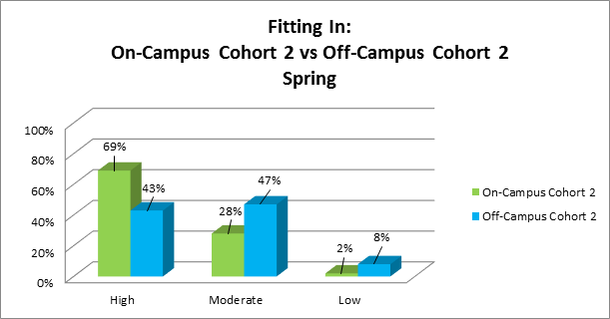
Survey Information
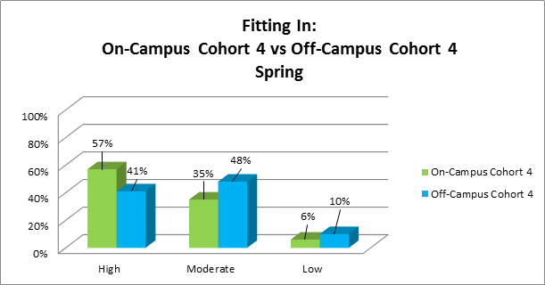
The data reflects the need for a Transfer Center. According to Mapworks--an early alert system used for student success and retention-- 48% of transfer students in Fall 2016 reported homesickness as their number one concern; 32% reported making friends or fitting in as the most difficult aspect of transferring to Appalachian; and 24.7% reported low peer connections. A physical space such as a Transfer Center would provide students with opportunities to create a stronger community during the difficult transition. The data also show differences in a student’s ability and perception of fitting in based on if they live on-campus or off-campus, regardless of if they transferred in the Fall or Spring semester. The charts show that off-campus students were not as successful at fitting in with their peers as the on-campus students. Survey cohort 2 are transfer students who first attended Appalachian State in Fall 2016 and survey cohort 4 are transfer students who first attended Appalachian State in Spring 2017. Within survey cohort 2, 69% of on-campus transfer students reported high feelings of fitting in while only 43% of off-campus students reported the same. Among survey cohort 4, 57% of on-campus transfer students reported high feelings of fitting and only 41% of off-campus transfer students felt the same. There were 201 students within cohort 2 living on-campus and 223 students living off-campus. Within survey cohort 4, there were a total of 127 transfer students living on-campus and 136 transfer students living off-campus.
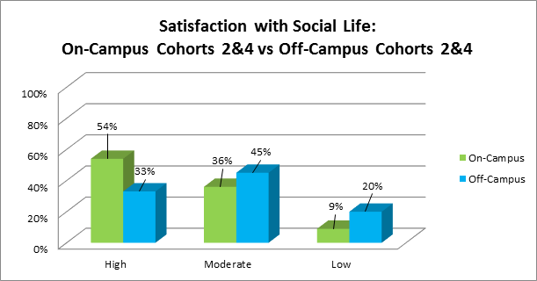
Off-campus students also differed in their satisfaction with social life when compared to transfer students living on-campus. From the Mapworks data, there is over a 20% difference in high satisfaction with social life when comparing on-campus to off-campus students. There were a total of 330 transfer students living on-campus and 360 transfer students living off-campus that responded to the survey. Based on the information from Mapworks, it is still important to create a space on campus for transfer students to connect with one another. For transfer students who live off-campus, it could be a space where they feel welcome to drop in and meet other students who are presumably going through similar situations and difficulties.

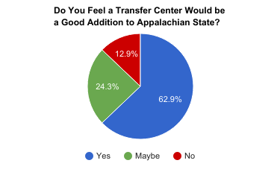
The Office of Transfer Services released a survey to all transfer students during the Spring 2017 semester via AppSync and received 161 responses. When asked “Do you feel a Transfer Center would be a good addition to ASU?”, 140 participants responded. 88 people answered “yes” and 34 answered “maybe” accounting for over 87% of the respondents who feel the transfer center could be a good addition to Appalachian. When asked their ideal vision of the space, some of the responses included:
  - A place to belong. A place where transfer students can go and meet other students with similar backgrounds. Help each other with homework. A sense of community among ourselves like other populations have on campus.
  - Friendly environment, easily accessible and easy to find on campus, welcoming atmosphere
  - An office where staff and transfer mentors can help students adjust to university life.
  - Having a central place on campus will help transfer students feel represented.

Survey respondents overwhelmingly wanted to see the center serve a social purpose, but also study space and a space to talk one-on-one with other transfer students.

2013 Recommendations
As stated earlier, the need for a physical space for transfer students is not a new finding by any means. Recommendations from the committee formed in 2013 echo that the same needs were prevalent four years ago. The Transfer Services Team was established by the Provost and Executive Vice Chancellor, Lori Gonzalez, in March 2013. The first charge of the Transfer Services Team was researching national trends related to transfer student success. The team used information gathered from other institutions, much like the research completed by the current Transfer Services Team. In 2013, the team initially identified 45 institutions of interest, and then selected 16 for further research. Eleven of those institutions have Transfer Services Centers or their equivalent. Some of the commons themes that arose from the research include the importance of having:

- A one-stop transfer student service center
- A one-stop transfer student website
- Peer mentorship

The 2013 Transfer Services Team made a final recommendation for a Transfer Services Center to be established at Appalachian:

“The Team’s vision for the Center is that it should serve as a welcoming first point of contact for transfer students. It should be a one-stop shop for transfer students, a place where they can go for mentoring and advice, and assistance in connecting with the resources they need to be successful at Appalachian. The Center should be a ‘home’ for transfer students, a place where they can meet people, make friends and develop a sense of community” (p. 19, The Transfer Services Team, Final Report).

The current Transfer Services Team has researched several peer institutions and has determined that the recommendations made in 2013 are still very relevant to our current transfer student population.

Transfer Students at Appalachian
Although Appalachian is considered a residential campus, 80% of new transfer students live off-campus. There are two Transfer Residential Learning Communities, but these communities are only able to accommodate roughly 100 transfer students out of the 1,266 students in the Fall of 2016. When 7 out of every 10 transfer students began at a community college, having a space for transfer students to connect is critical when many will not be living on-campus. According to MAPWorks and a study conducted by University Housing in Fall 2013, transfer students who live on campus show an overall lower risk factor than students living off campus. 88% of transfer students at Appalachian are between 18 and 23 years of age, falling within a traditional age range. The average age for incoming transfer students since the Fall of 2009 has been 21, with the range for Fall 2017 spanning a low of 17 and a high of 75 years old.

Other Universities
The current Transfer Services Team researched and analyzed fourteen other universities across the United States that have a Transfer Center or related center in place. The universities were selected because they responded to a query sent by Appalachian’s Office of Transfer Services via the National Resource Center Transfer Year Experience listserv. Of the fourteen researched, eleven of the universities responded to an email sent out for further questions. A Transfer Services Team representative spoke with a staff member from all eleven schools that were willing to be interviewed. The selected universities and transfer centers vary widely in terms of student populations, goals, and organizational structure, but there are several similarities to Appalachian. Many of the universities offer support for prospective transfer students in the form of credit evaluation, campus visits, etc. Some also have very similar student populations to Appalachian, with most transfer students falling in a traditional age range. The fourteen universities are listed in the table below:

Murray State, Kentucky | Southern Oregon University
Texas Christian University | The University of Arizona
UC Berkeley | UC Davis
UC Irvine | UC Santa Barbara
UCLA | University of North Texas
University of Texas at Austin | Virginia Commonwealth University
University of Cincinnati | Western Kentucky University

There was variation among the centers in terms of year established, organizational structure, presence of student workers, location on campus, types of events and programming, as well as partnerships of which each took advantage. While some centers were housed within Academic Affairs (as OTS is), others were more aligned with Student Affairs, but regardless of their place within their university structure the successful centers had several themes in common which Appalachian should strive to emulate. Those themes included:

- A version of student mentors/peer educators/transfer assistants/community peer mentor
- Active partnerships with other offices on campus (Admissions, Veteran’s center, Housing)
- Space individuals or groups can use to study/hang out/hold meetings
- A central location on campus
- Some planned events or programming
- Student and upper leadership support

All eleven universities who were interviewed in-depth have some form of student assistance in the transfer centers. This varies from those who simply have front-desk workers to centers who have 85 participants in a one-on-one mentoring program. Appalachian’s Office of Transfer Services has had an established mentoring program since Spring 2012 and the Transfer Student Mentors would be an invaluable asset in assisting with day-to-day operations in the center. The 15 student mentors would be responsible for greeting incoming transfer students and assisting OTS with any programming in the center, but we can also take ideas and learn from other universities. While the office strives to maintain a diverse group of mentors in terms of major, all programs are not represented. UC Berkeley organizes a Major Insights Mentoring program where students meet with incoming students in the same major, but it is not a full-semester responsibility. The University of North Texas has a Transfer Community Peer Mentor program where mentors lead a group of students that have a similar interest, such as Outdoor Pursuits.

Several universities expressed the importance of maintaining partnerships with other offices across campus. The University of Arizona has a program entitled Faculty Fellows; participating faculty members receive a small stipend to help with events and have an office hour in the transfer center each week, Appalachian State already has a program in place called Transfer Faculty Mentors. These faculty members have expressed interest in becoming more aware of the path transfer students experience in transitioning to Appalachian. This program could be expanded to have a presence within the transfer center to talk to students who are having difficulties transitioning into the academic rigor of a four-year university.

Through conversations with other universities who have established transfer centers, it is easy to recognize that each university is different and many are in different stages of development. Most transfer resources begin with an academic and credit focus, but then may move to a more student services approach for retention purposes. Appalachian State is one of the leading schools in terms of transfer services in the nation and often presents our framework at the National Institute for the Study of Transfer Students conference. It is time to take the next step to provide more services to transfer students once they arrive on campus. Transfer students at App make up 34% of new students each year and this number will continue to rise as more students opt to attend community college before matriculating to a four-year institution due to costs.

Center Priorities
Based on review of feedback from current Appalachian transfer students, comparison of Transfer Centers at peer institutions as well as analysis of MapWorks Data, the Transfer Services Team has outlined the primary purposes that the transfer center would fulfill at Appalachian. The primary priorities include having a space that is centralized on campus in order to maximize the center’s ability to attract transfer students across campus and facilitate engagement among the students. Because transfer students reported wanting a Transfer Center for social purposes, an open space would be essential. The center will be managed by the Office of Transfer Services’ Associate Director as well as a Graduate Assistant to aid in programming. The center will be staffed by Transfer Student Mentors who will be available to answer questions or talk to current students who visit the center. The Mentors will maintain “office hours” within the center to ensure a student will be available during the center’s hours of operation. The center will be staffed from 9:00am-5:00pm, but will remain open to visitors after business hours. The Transfer Student Mentors will have a desk where they may complete their office hours.

The center will have open space for transfer students to interact in a small social setting at any point throughout the week. The open space will also serve as a meeting point to invite campus partners to facilitated events and programs. After hours, the center’s space will be utilized by our Transfer Student Organization as well as Tau Sigma, our Transfer Honor Society, to hold officer meetings or related club meetings. This space will consist of several tables as well as desk chairs for students to complete coursework.

Due to the fact that the center is in-part geared toward attracting off-campus transfer students as well, a secondary priority is to have a refrigerator and/or a microwave for students to utilize. Providing services specifically designed for off-campus students would help increase their satisfaction with social life and help with their sense of belonging and fitting in, addressing the Mapworks concerns for off-campus transfer students.

Projected Budget
One-time costs of renovation of space/furniture & equipment: $50,000
Graduate Assistant to help staff the Center: $9,000/year

Conclusion
In February 2017, an Appalachian State transfer student posted the following post on a townwide Facebook group:
“So this is my second semester living here, and I’m so miserable that I have no idea what to do with myself. Before this, I graduated high school in New Jersey and attended Colorado State University. It was an absolute dream come true. Due to some unfortunate family circumstances, I had to leave CSU and move to my parents new home in Charlotte. I stayed in Charlotte for two excruciatingly lonely years before transferring here to App. I picked this school for the price, and because I thought I would once again find a sense of belonging and happiness and contentment up in the mountains. Trust me, I came here this August with the highest hopes and the most open mind, because frankly I had suffered too much to go out of my way to find negativity. So I’ve been holding my head up, but...this year really hasn’t turned out how I had planned. I’ve had a lot of awful and negative experiences with other people, which isn’t something I’ve ever experienced much of before. My roommate situation has amplified my anxiety to an unbearable level. I’ve had a lot of great professors, I’ve briefly met a lot of people who seemed genuinely interesting and likeable-but a deeper friendship never developed. In short I’m writing this as a desperate attempt to display my own vulnerabilities and invite positivity and change into my life. I know there must be potential to create a happy life here, and I’m determined to pursue that. I just don’t want to feel alone and unhappy here anymore, so I’m risking the embarrassment of telling the truth of my not-so-glamourous life in hopes of inspiring some of you beautiful people out there to come and help me out of the dark”.

The response was overwhelming with over 100 people (including staff and mentors from OTS) reaching out to the student expressing support, similar feelings, and offering to meet. This is the type of student that the proposed Transfer Center aims to help. Transfer students come to Appalachian excited and hopeful but may find it hard to break into already formed social circles and are hesitant to walk in alone to a student event or club meeting. With most living off campus the obstacles are even greater. A center would provide students a welcoming place for transfer students to gather similar to our other centers on campus that serve subpopulations of students, serve students experiencing transitional difficulties, and offer support from Transfer Student & Faculty Mentors. The center would help alleviate the transfer shock that can plague our students. Transfer shock is the academic and social disorientation experienced by students following a transfer from one institution to another that may result in a temporary drop in GPA. By providing support through the Transfer Center we anticipate more engaged transfer students with higher retention and graduation rates.

