Transfer Task Force

Appalachian State University

Final Report

May 30, 2008
TABLE OF CONTENTS

TASK FORCE MEMBERS 3
TRANSFER TASK FORCE FINAL REPORT 4
Charge for the Task Force 4
Transfer Students Defined 5

RESPONSES TO THE CHARGE 5
Response to Charge 1 5
Response to Charge 2 6
Response to Charge 3 7
Response to Charge 4 7
Response to Charge 5 8
Response to Charge 6 8
Response to Charge 7 9

RECOMMENDATIONS 10

REFERENCES 12

APPENDICES 13
Appendix 1 14
ASU General Education Curriculum Model
Appendix 2 21
Comprehensive Articulation Agreement
Appendix 3 31
Goals for General Education Comparison Chart
Appendix 4 33
Community College to ASU Equivalencies
Appendix 5 41
Proposal for Office of Transfer Articulation

Task Force Members

Dr. Jeni Wyatt, Chair College of Arts & Sciences, ASU
Mr. Doug Allen Counselor, Catawba Valley Community College
Ms. Dawn Bare University College Advising, ASU
Dr. Doris Bazzini Department of Psychology, ASU
Ms. Diana Beasley Teacher Education Recruitment, ASU
Ms. Sarah Davis-Cagle Office of Admissions, ASU
Mr. Wingate Cain Transfer Counselor, Western Piedmont Community College
Dr. Lynne Getz Department of History, ASU
Ms. Carter Hammett-McGarry University College, ASU
Ms. Blair Hancock Dean, Arts & Sciences, Wilkes Community College
Mr. Gordon Hensley Department of Theatre & Dance, ASU
Dr. Rebecca Kaenzig Department of Accounting, ASU
Ms. Brenda Lyerly Office of Admissions, ASU
Dr. Mike Mayfield University College, ASU
Dr. Priscilla Porterfield School of Music, ASU
Ms. Misti Reese Office of Admissions, ASU
Ms. Kimberly Turk Vice President of College Transfer, Caldwell Community College & Technical Institute
Ms. CynD Weaver Office of Extension & Distance Education, ASU
Dr. Ray Williams Department of Biology, ASU
Ms. Martha Wilson Registrar’s Office, ASU
Ms. Judy Winebarger Coordinator, Academic Advising Center,
Caldwell Community College & Technical Institute-Watauga Campus
Dr. Jami Woods Associate Vice President for Curriculum Programs –
Surry Community College

Final Report of The

Transfer Task Force

The Transfer Task Force was established by the Vice Provost for Undergraduate Education, David Haney, in November, 2007, to address the way transfer credit will be articulated in regards to Appalachian State University’s (ASU) new General Education program. The new general education program (Appendix 1), described in the General Education Task Force Final Report, will be implemented beginning with the fall 2009 semester. The Task Force first met in late November, 2007, to accept the charge for the task force and to review ASU’s new general education model and the Comprehensive Articulation Agreement. A plan was established in early spring semester 2008 to begin looking at North Carolina community college transfer issues first and then to broaden our scope by looking at transfer issues from other institutions.

In this report, we summarize our plan for accepting transfer credit for Appalachian’s new general education program. The report will answer the questions in the charge from the vice provost.

Charge for the Task Force

This task force is charged with recommending policies and procedures for articulating transfer credits under Appalachian’s new general education program. The task force should be sensitive to the needs of the institutions from which and to which students are transferring, while focusing primarily on the needs of students. Working within the current statewide articulation agreement, but with the understanding that this agreement is currently under discussion and revision, the task force should address the following questions:
- How can we assist transfer students in meeting the goals and outcomes of Appalachian’s general education program?
- How can the need for ease of credit transfer be balanced with the unique aspects of Appalachian’s general education curriculum?
- What kinds of credits can be transferred automatically and what kinds will need to be handled on a case-by-case basis?
- Who will make case-by-case decisions and how will consistency be insured?
- How can our decision-making processes be best informed by and communicated to the institutions from which students transfer?
- How can we work toward an outcomes- rather than course-based approach to transfer credit?
- How can we promote continued dialogue between Appalachian and our feeder schools (both 4-year and 2-year institutions) around transfer issues?

Transfer Students Defined

There are several types of transfer students, and each type has different needs for transfer evaluation. The Task Force began their work with transfer students from the North Carolina Community College System (NCCCS) since the articulation agreement has specific requirements for the evaluation of transfer work.

Transfers with AA or AS degrees or with the 44-hour core met

The Comprehensive Articulation Agreement (2007) states that students who have completed an Associate of Arts (A.A.) or an Associate of Science (A.S) degree at a NC community college will transfer into one of the 16 University of North Carolina (UNC) institutions with junior status (Appendix 2). In addition these students and those who have completed the 44 hour general education core (defined in the agreement) will be considered to have met the institution-wide, lower-division general education requirements of the accepting institution. Therefore, ASU will consider these transfer students to have met the general education requirements except for the Junior Writing in the Major course and the Senior Capstone in the Major course.

Transfers with less than a degree or no core met

These transfer students may come from the community college system or any other institution. Students will have their work evaluated course-by-course in keeping with University policy and the procedures explained in this report.

First-Year students who have transfer work

Many first-year students (e.g., those who have graduated high school within one year of matriculation) are earning some sort of college credit prior to their first semester on-campus at ASU. This work may be from many different programs such as Huskins courses; Dual Enrollment; Learn and Earn high schools; and Learn and Earn Online. This coursework is considered college coursework and will be evaluated as any other transfer work described in this report.

RESPONSES TO CHARGE

1. How can we assist transfer students in meeting the goals and outcomes of Appalachian’s general education program?

Appalachian State University’s new general education curriculum is “grounded in a liberal education in the arts and sciences” throughout a student’s entire academic career (General Education Task Force [GETF], 2007, p. 7). The education goals for general education at ASU are: (1) Thinking Critically and Creatively, (2) Communicating Effectively, (3) Making Local to Global Connections, and (4) Understanding Responsibilities of Community Membership (GETF). The curriculum also “advocates integrative learning through thematic coursework in four Perspectives: Aesthetic, Historical and Social, Local to Global Connections, and Science Inquiry” (GETF, p. 7). The goals of the curriculum are intended for all students, native and transfer students alike. However, students who transfer to ASU with their general education complete will not experience the complete curriculum. The Junior Writing in the Major course and the Senior Capstone in the Major course will be required of these students and where they will be certain to experience some type of focus on the general education goals. In addition, up to nine semester hours of courses from within themes may be used to meet major requirements; therefore, transfer students may even take courses within a theme for major credit but still receive the benefit of the general education experience.

Those students who transfer in a fewer number of credit hours will more likely be able to meet the goals and outcomes of the general education. Their transfer work will be evaluated on a course-by-course basis and are not likely to have met all the requirements for general education. This will allow them to experience a more complete version of the general education curriculum.

It will be critical for the university and the representatives from the community colleges to continue the communication the task force has begun about general education and transferability. Appalachian must keep the community colleges updated about themes within the perspectives, as well as any changes to the goals and outcomes, so that the community college advisors can assist their students in making wise choices for courses that will transfer as needed.

2. How can the need for ease of credit transfer be balanced with the unique aspects of Appalachian’s general education curriculum?

The Task Force began by reviewing the goals and outcomes for general education at the top feeder community colleges for our institution. This review found very similar goals and outcomes for general education at the community colleges as was developed at Appalachian (Appendix 3), and it also revealed similar approaches to learning and pedagogies. The approach Appalachian takes toward meeting the goals and outcomes of general education is unique; however, the similarity among institutions of underlying educational goals will enable the transfer of credit to be more soundly based upon goals and outcomes rather than just upon disciplines or titles of courses as done in years past.

Clearly the work accomplished to date by the Transfer Task Force will need to be continued by an identified unit within the University. Specifically, communication between and among community colleges (at least those considered as top feeders for Appalachian transfer students) and the University will be critical. Appalachian transfer representatives gaining an understanding of community college course outcomes will enable more appropriate determinations in awarding transfer credit. Transversely, the community college representatives having a better awareness of ASU’s General Education Curriculum will allow them to provide better information regarding course selections for their students who are planning to transfer.

3. What kinds of credits can be transferred automatically and what kinds will need to be handled on a case-by-case basis?

Since the NCCCS and the UNC system already have an articulation agreement in place, the Task Force began the process of determining which courses could be transferred in automatically. The Task Force spent several meetings reviewing the North Carolina Community College General Education Core courses from the Comprehensive Articulation Agreement to ascertain to which components of the new ASU General Education model these courses would articulate. A comprehensive examination of the courses at the community colleges included reviewing the course descriptions from the Common Course Library and individual institutions’ catalogs, discussing the methods of instruction for the courses, and using the knowledge of our community college representatives about the courses at their respective institutions. This information for each course was compared to the goals and outcomes for the various components in the ASU general education model, as stated in the General Education Task Force Final Report, to determine the best fit for transfer credit. The Task Force completed a chart that shows where each of these courses will automatically transfer in to ASU’s general education curriculum. (Appendix 4)

Courses outside the NCCCS General Education Core courses will be evaluated based upon perceived course outcomes of the transferred courses. The use of course descriptions, syllabi, and other supporting documents will be used to attempt a match to an equivalent ASU general education course.

4. Who will make case-by-case decisions and how will consistency be insured?

Currently, Admissions consults with appropriate department chairs to make decisions regarding any transfer work that does not automatically articulate. Sometimes the student must communicate directly with the respective department chair in order for the determination to be made. For future transfer course considerations, each course will be evaluated based upon perceived/described course outcomes. The course descriptions, syllabi, and other supporting documents available for the course will be used to determine how the course best fits into the goals and perspectives of ASU’s general education curriculum. This documentation may be reviewed by the appropriate department chair to gain additional input to determine course equivalency.

Appalachian State University has plans for the creation of an Office of Transfer Articulation (Appendix 5) that is slated to begin work sometime prior to the implementation of the new general education curriculum. This office will be responsible for working with department chairs, Admissions, the Registrar’s Office, and the Director of General Education to ensure the proper evaluation of transfer credit. In addition, this office will maintain a database so that once a course from a specific institution has been evaluated, subsequent students with the same transfer work will receive the same credit. This consistency of evaluation will be important for transfer students and for advisors at community colleges who will advise students who plan to transfer to ASU.

Prior to the opening of this office, Admissions will be required to continue their work evaluating transfer work. It will be necessary for Admissions to work closely with department chairs and the Director of General Education to properly assign credit to courses outside the automatically articulated Community College General Education Core courses. Maintenance of records of any evaluation of courses must be maintained to assist the Office of Transfer Articulation once it begins the evaluation process.

5. How can our decision-making processes be best informed by and communicated to the institutions from which students transfer?

Courses will be evaluated based upon course outcomes of the transferred courses. The use of course descriptions, syllabi, and other supporting documents will be used to attempt a match to an equivalent ASU general education course. The process and the information the student must provide should be described on the website for transfer students and for advisors from other institutions. In addition, the meetings held between ASU and the community college representatives will assist in communicating the expectations of both parties.

The university should arrange to visit the top feeder community colleges to meet advisors and discuss the general education curriculum to explain the benefits to students and to answer questions. In addition, the university should have representatives attend meetings of the College Transfer Program Association (CTPA), the North Carolina Community College System, and the Transfer Advisory Committee.

6. How can we work toward an outcomes- rather than course-based approach to transfer credit?

Regional accreditation bodies are requiring institutions to rethink learning in terms of goals and outcomes, so many, if not most, of the community colleges in North Carolina already focus on course outcomes or will be soon. It would seem that tapping into that information available would provide the impetus for establishing transferability based upon outcomes rather than strictly on course content. In addition, continued communication between the university and the community colleges regarding goals and outcomes for general education will facilitate increasing understanding of how students can be best served when moving among institutions.

7. How can we promote continued dialogue between Appalachian and our feeder schools (both 4-year and 2-year institutions) around transfer issues?

It will be important for those responsible for evaluating transfer work at the University and those key personnel at our feeder community colleges to continue meeting on a regular basis. At a minimum, these people should meet once per semester to discuss new/changed courses and to give and receive feedback regarding the successes or challenges for students who are moving among institutions. The process used by the Task Force (see response to Question 3 above) could be replicated as new courses or changes to courses and curricula are made. In addition, the community college representatives requested a website that is continually updated with information regarding new themes within the perspectives as well as any new community college courses that have been evaluated for transfer. This website should also allow for communication via email, blogs, or message boards from the community college representatives to the University so that any issues can be brought to attention quickly without waiting for a face-to-face meeting.

RECOMMENDATIONS

Based upon the work done during the semester, the Task Force makes the following recommendations:

1. Establish an Office of Transfer Articulation/Services sooner rather than later.

The Office of Transfer Articulation/Services will be a vital requirement for transfer students and the university. The amount of transfer work will continue to rise as admissions requirements for first-year students become more stringent and as more students take advantage of dual enrollment programs during high school. This office will be the clearinghouse for students, advisors at other institutions, and ASU advisors alike. The Task Force was excited to learn of the initiative to develop this office, but then we were disheartened to hear the possible opening will be postponed until a later date. The community college representative members of the Task Force stressed that they are already advising ASU’s 2009 transfer students. These students are registering now for courses they hope will meet requirements for their Historical and Social Perspective or Aesthetic Perspective or other aspect of the new general education. Currently, ASU has no centralized office or person of contact potential transfer students or their advisors can easily find for assistance. This office would be invaluable to these people.

Additionally, ASU’s Admissions office has been overwhelmed with applications for admissions over the past two years, with over 13,000 last year and upwards of 15,000 for 2007-08 (M. Reese, personal communication, May 2, 2008). Based on data from the fall 2007 cohort, it is estimated that 35-40% of all of these applications have some sort of transfer work to be articulated (H. Langdon, personal communication, May 27, 2008). Currently, the Admission office is responsible for evaluating this work in addition to their workload of recruiting and selecting qualified students. Admissions representatives are not prepared to answer questions from potential transfer students and advisors from other institutions who have questions about the new general education requirements, but without the proposed office, there is no unit on campus prepared to assist them. Therefore, the Task Force recommends the Office of Transfer Articulation/Services be opened by this fall.

2. Convene a General Education Transfer Communication Committee

An on-going joint committee of ASU and community college representatives should meet at least twice per semester to keep each other up-to-date on curriculum, goals and outcomes of general education, and the practical applications of transferability. The committee members should have rotating membership terms to provide continuity in making decisions. The chair of this committee may be someone from the Office of Transfer Articulation/Services, University College, or a faculty member who is interested in this topic. This committee could rotate meeting sites among the community colleges and the University in order to visit each site and its advisors in order to personally answer questions and express appreciation. The committee should work with the Office of Transfer Articulation/Services to provide regular updates regarding general education to the university and the community colleges. These updates should include a list of all themes and the courses within the themes, along with their “expiration dates.”

3. Provide a website for transfer articulation information

Appalachian should develop a website as a resource for faculty, students, and transfer advisors to provide information about course transferability. This website could be linked in some way to the database the Office of Transfer Articulation/Services will keep so someone can enter a specific course from a specific institution to find out how it will transfer to ASU.
In addition, the website can offer a resource section with information on the Comprehensive Articulation Agreement, transfer policies and procedures, and advising support.

4. ASU participation in CTPA, NCCCS annual meetings, TAC, etc.
A few ASU representatives attended the College Transfer Program Association (CTPA) conference in April, and some of them even joined the association. Those who attended felt the conference was very informative. The association meets twice per year. The director and assistant director of the Office of Transfer Articulation/Services (and possibly other in University College) should become members of and participate in this association. The North Carolina Community College System (NCCCS) holds annual meetings that include discussions and break-out sessions about transfer issues. Appalachian should have representatives attend these meetings as well. The Transfer Advisory Committee (TAC) is a joint committee of the NCCCS and UNC system that is charged with reviewing complex transfer issues and making recommendations to deal with these issues. It would be beneficial to have someone from ASU attending these meetings, if possible.

5. ASU support for faculty

The Office of Transfer Articulation/Services or University College or another assigned unit should create educational programs for academic departments and program advisors that inform them about transfer courses and how ASU has decided to deal with transfer credit. This faculty development will enable departments to provide good direction for students when they go to departments for articulation issues or advice. In addition, the Task Force suggests that ASU sponsor a yearly colloquium for ASU and community college faculty partners to promote cross institutional dialogs on best practices in teaching. This will also provide time for these same-discipline faculties to discuss goals and outcomes which will assist with articulating courses for transfer.

6. Assessment

Appalachian must assess how well transfer students acclimate and perform once they are students on our campus. The assumption that transfer students will perform differently since they will not have experienced the complete general education curriculum must be tested. The data generated should be used to justify what we are doing or to make changes in services provided to transfer students.

REFERENCES

Comprehensive articulation agreement between The University of North Carolina and the North Carolina Community College System. (2007). Retrieved January 22, 2008, from The University of North Carolina website: http://www.northcarolina.edu/content.php/assessment/reports/student_info/caa.htm

General Education Task Force. (2007). Final Report. Retrieved May 30, 2008, from Appalachian State University, General Education website: http://generaleducation.appstate.edu/files/filecabinet/documents/Final_Report_5-9-07.pdf

APPENDICES

Appendix 1

Appalachian State University

General Education Curriculum Model

(For complete description, see General Education Task Force Final Report at: http://generaleducation.appstate.edu/files/filecabinet/documents/Final_Report_5-9-07.pdf

Curriculum Model

The general education curriculum model requires a total of 44 semester hours (see Diagram 1).

This includes the following required coursework:
3 s.h. First Year Seminar
3 s.h. First Year Writing
3 s.h. Sophomore Writing
4 s.h. Quantitative Literacy
2 s.h. Wellness Literacy
----- Information and Communication Technology Literacy (to be determined)
29 s.h. Perspectives (including 3 s.h. each in fine arts, historical studies, literary studies)
_____
44 s.h. TOTAL

Coursework in the major:
Junior Writing
Senior Capstone Experience

In order to encourage a broad-based general education, most courses for students will be outside their majors. Students will be allowed to count a maximum of two courses taught in their majors toward general education requirements (up to 8 s.h. of the total 44 s.h.).

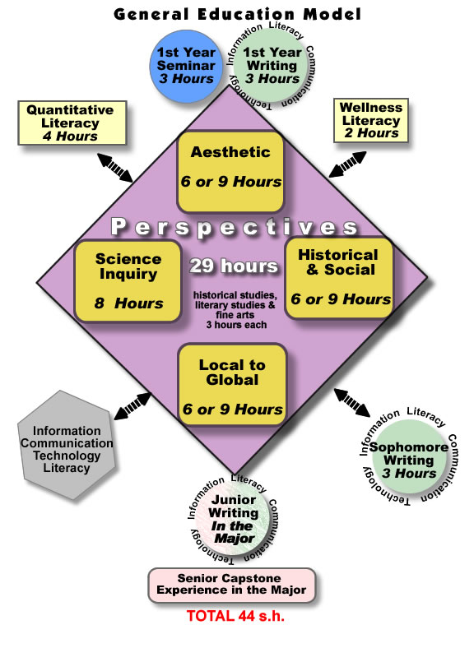
Diagram 1 - General Education Model

NOTE: The term “literacy” is used in this model to indicate the acquisition of knowledge in a particular subject or area of activity, an understanding of the process of acquiring that knowledge, and an understanding of the application of that knowledge.

GENERAL EDUCATION CURRICULUM MAP-TABLE 2
The purpose of a curriculum map is to identify where within the general education curriculum each learning outcome is addressed. To ensure that every student has the opportunity to achieve every outcome, the matrix below shows the minimal general education learning outcomes that should be addressed by each general education curricular component. We recommend that the curriculum map be revisited each year to determine if any revisions need to be made and to ensure that there are not any gaps in the curriculum. The curriculum map is also an important tool for assessment. Those charged with assessment of general education will look to the map for guidance in identifying appropriate time points for conducting assessment activities and in identifying courses for collecting samples of student work relative to a particular learning outcome.

Table 2 – General Education Curriculum Map
 | General Education Curricular Components
Learning Outcomes | First Year Seminar | Quantitative Literacy | Wellness  Literacy | ICT Literacy | Freshman Writing | Sophomore Writing | Junior Writing | Historical and Social Perspectives | Aesthetic Perspectives | Science Inquiry | *Local to Global Perspectives
Goal 1: Thinking critically and creatively
A. Recognize, differentiate, and effectively employ appropriate and increasingly sophisticated strategies to collect and interpret information | X |  |  | X | X | X | X | X
B. Successfully integrate disparate concepts and information when interpreting, solving problems, evaluating, creating, and making decisions | X | X | X |  | X | X | X |  | X | X
C. Examine and evaluate how their own personal, historical, and cultural perspectives affect the discovery and generation of knowledge | X |  |  |  | X |  |  | X | X
D. Construct persuasive arguments in increasingly complex contexts |  | X |  |  | X | X | X
E. Apply theories from a variety of disciplines and advance convincing reasons to connect as well as differentiate theories from different domains of knowledge. | X |  |  |  |  | X |  | X | X
Goal 2: Communicating Effectively
A. Articulate and comprehend effectively, using verbal or non-verbal communication suitable to topic, purpose, and audience | X |  |  |  | X | X | X |  | X | X
B. Use writing effectively to discover and develop ideas and to articulate positions in contexts of increasing complexity | X |  |  |  | X | X | X
C. Make rhetorical decisions appropriate to topic, purpose, and audience while correctly using the conventions of standard written English |  |  |  |  | X | X | X
D. Determine the scope of information needed in specific research contexts and successfully identify, locate, evaluate, use, and communicate information from various media |  |  |  | X | X | X | X
E. Read actively and analytically at the college level and synthesize and apply information and ideas from their reading across disciplines |  |  |  |  |  | X | X | X
F. Know, apply, and communicate college-level quantitative concepts and methods |  | X |  |  |  |  |  |  |  | X
G. Select and use hardware, software applications, databases, and other technologies effectively for both inquiry and communication |  | X |  | X | X | X | X
Goal 3: Making Local to Global Connections
A. Analyze past and present relationships between humans and the natural and physical environment |  |  |  |  |  |  |  |  |  | X | x
B. Evaluate community, natural, and global change through the lens of sustainability |  |  |  |  |  |  |  |  |  | X | x
C. Demonstrate the ability to think critically and creatively about the relationship between local regions and global issues, processes, trends, and systems |  |  |  |  |  |  |  | X |  |  | X
D. Demonstrate knowledge of contemporary issues related to cultural diversity in the United States and other areas of the world |  |  |  |  |  |  |  | X | X |  | x
E. Employ appropriate and increasingly sophisticated means for communicating with people of other cultures |  |  |  | X |  |  |  |  |  |  | X
Goal 4: Understanding Responsibilities of Community Membership
A. Identify potential consequences that personal choices as well as political, economic, and other social forces may have on individual, societal, and environmental health |  |  | X |  |  |  |  | X
B. Apply moral reasoning skills to an array of ethical issues confronted by individuals, groups, and communities |  |  |  |  |  |  |  | X
C. Collaborate effectively with others in shared processes of inquiry and problem solving | X | X |  |  | X | X | X |  |  | X
D. Apply principles of responsible community membership within and beyond the campus community |  |  |  |  | X | X | X
4
Appendix 2

Comprehensive Articulation Agreement

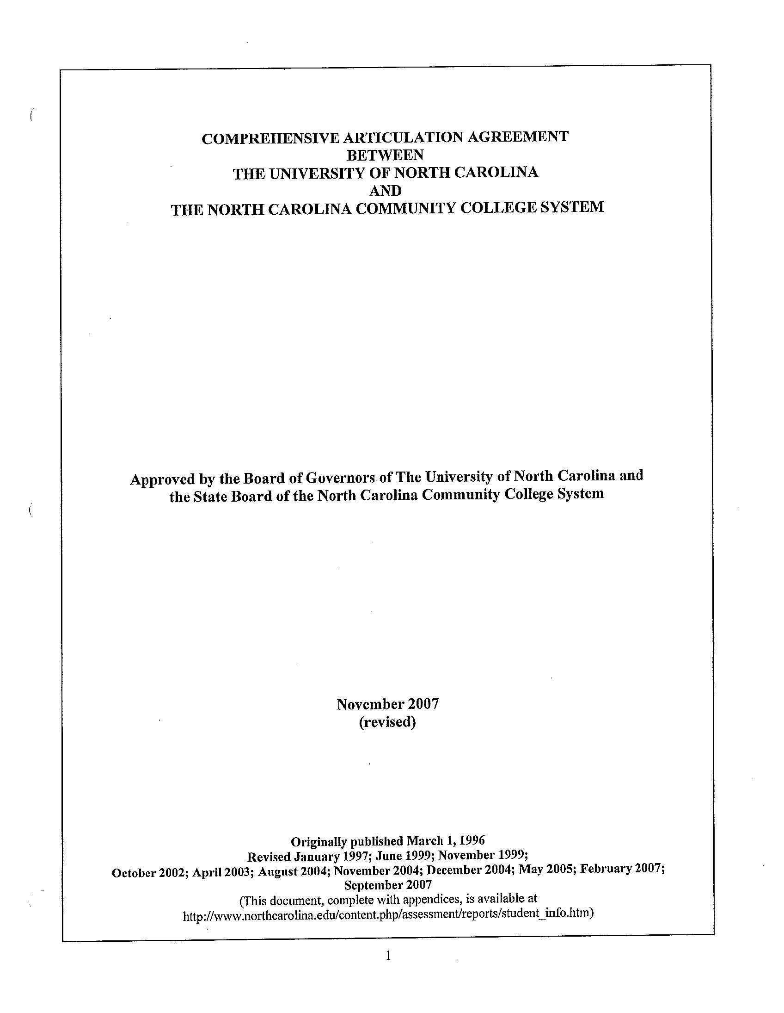
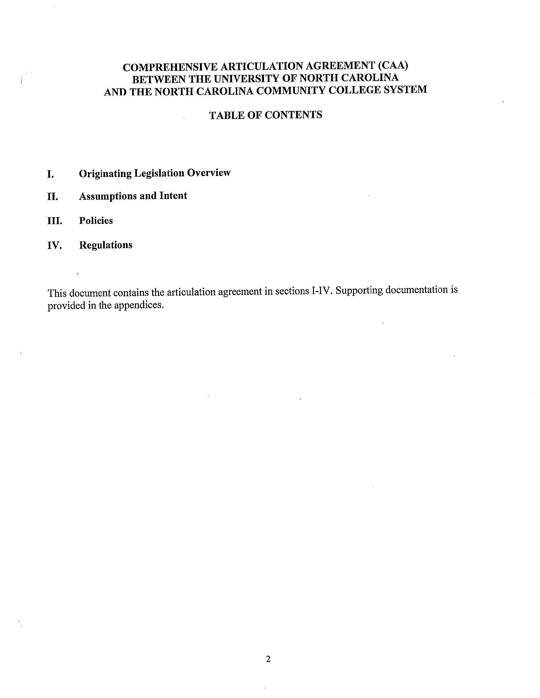

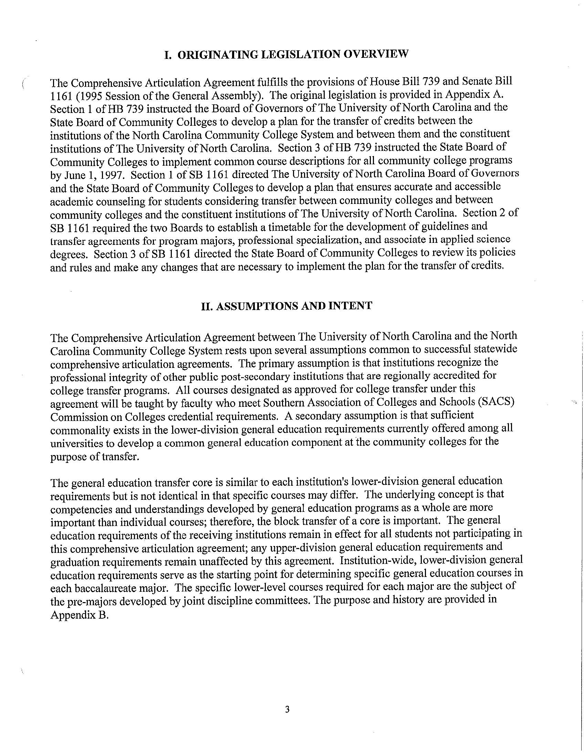
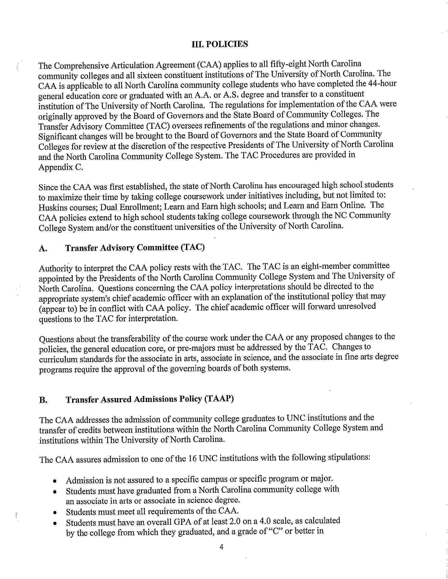
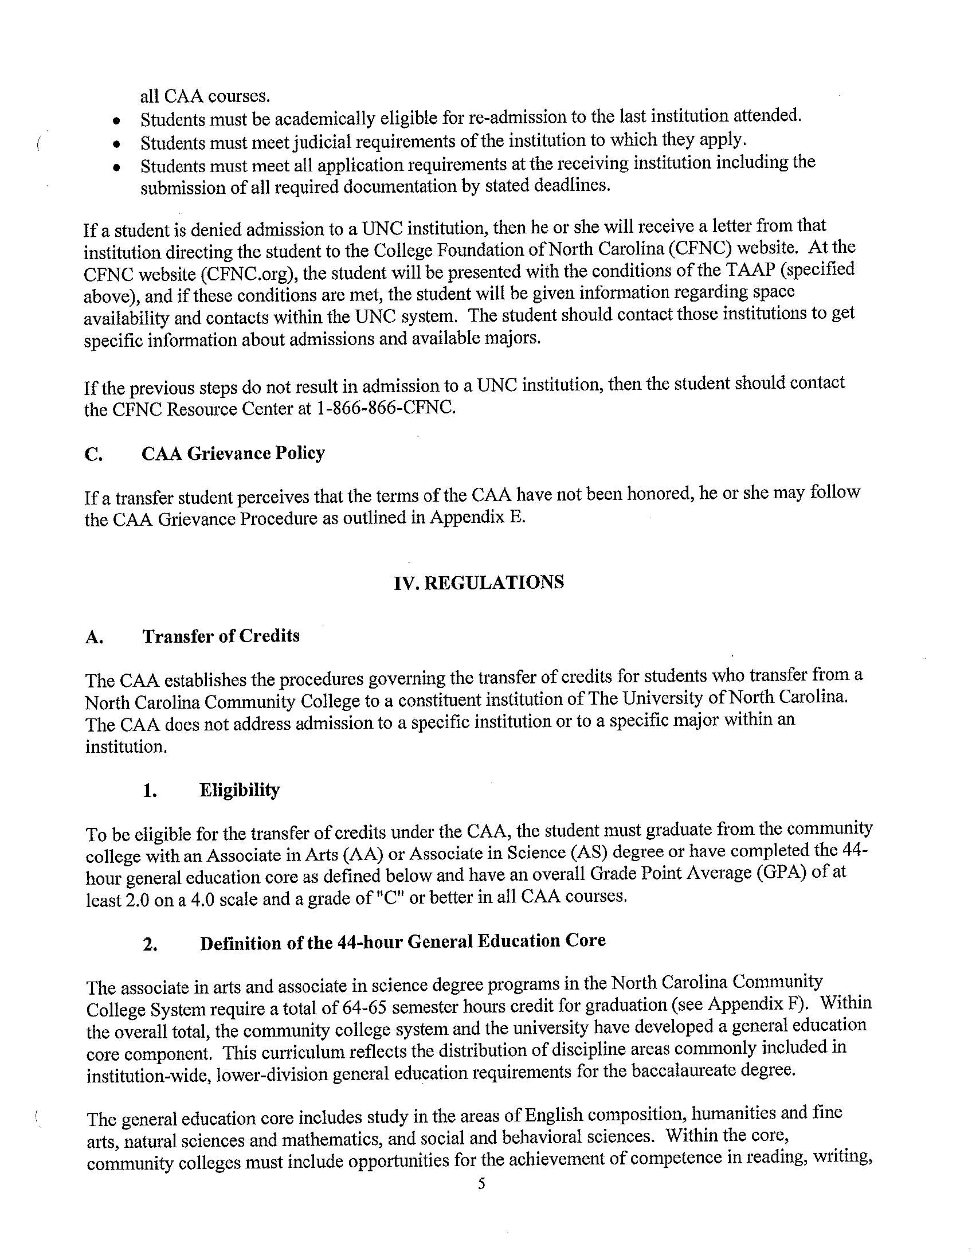

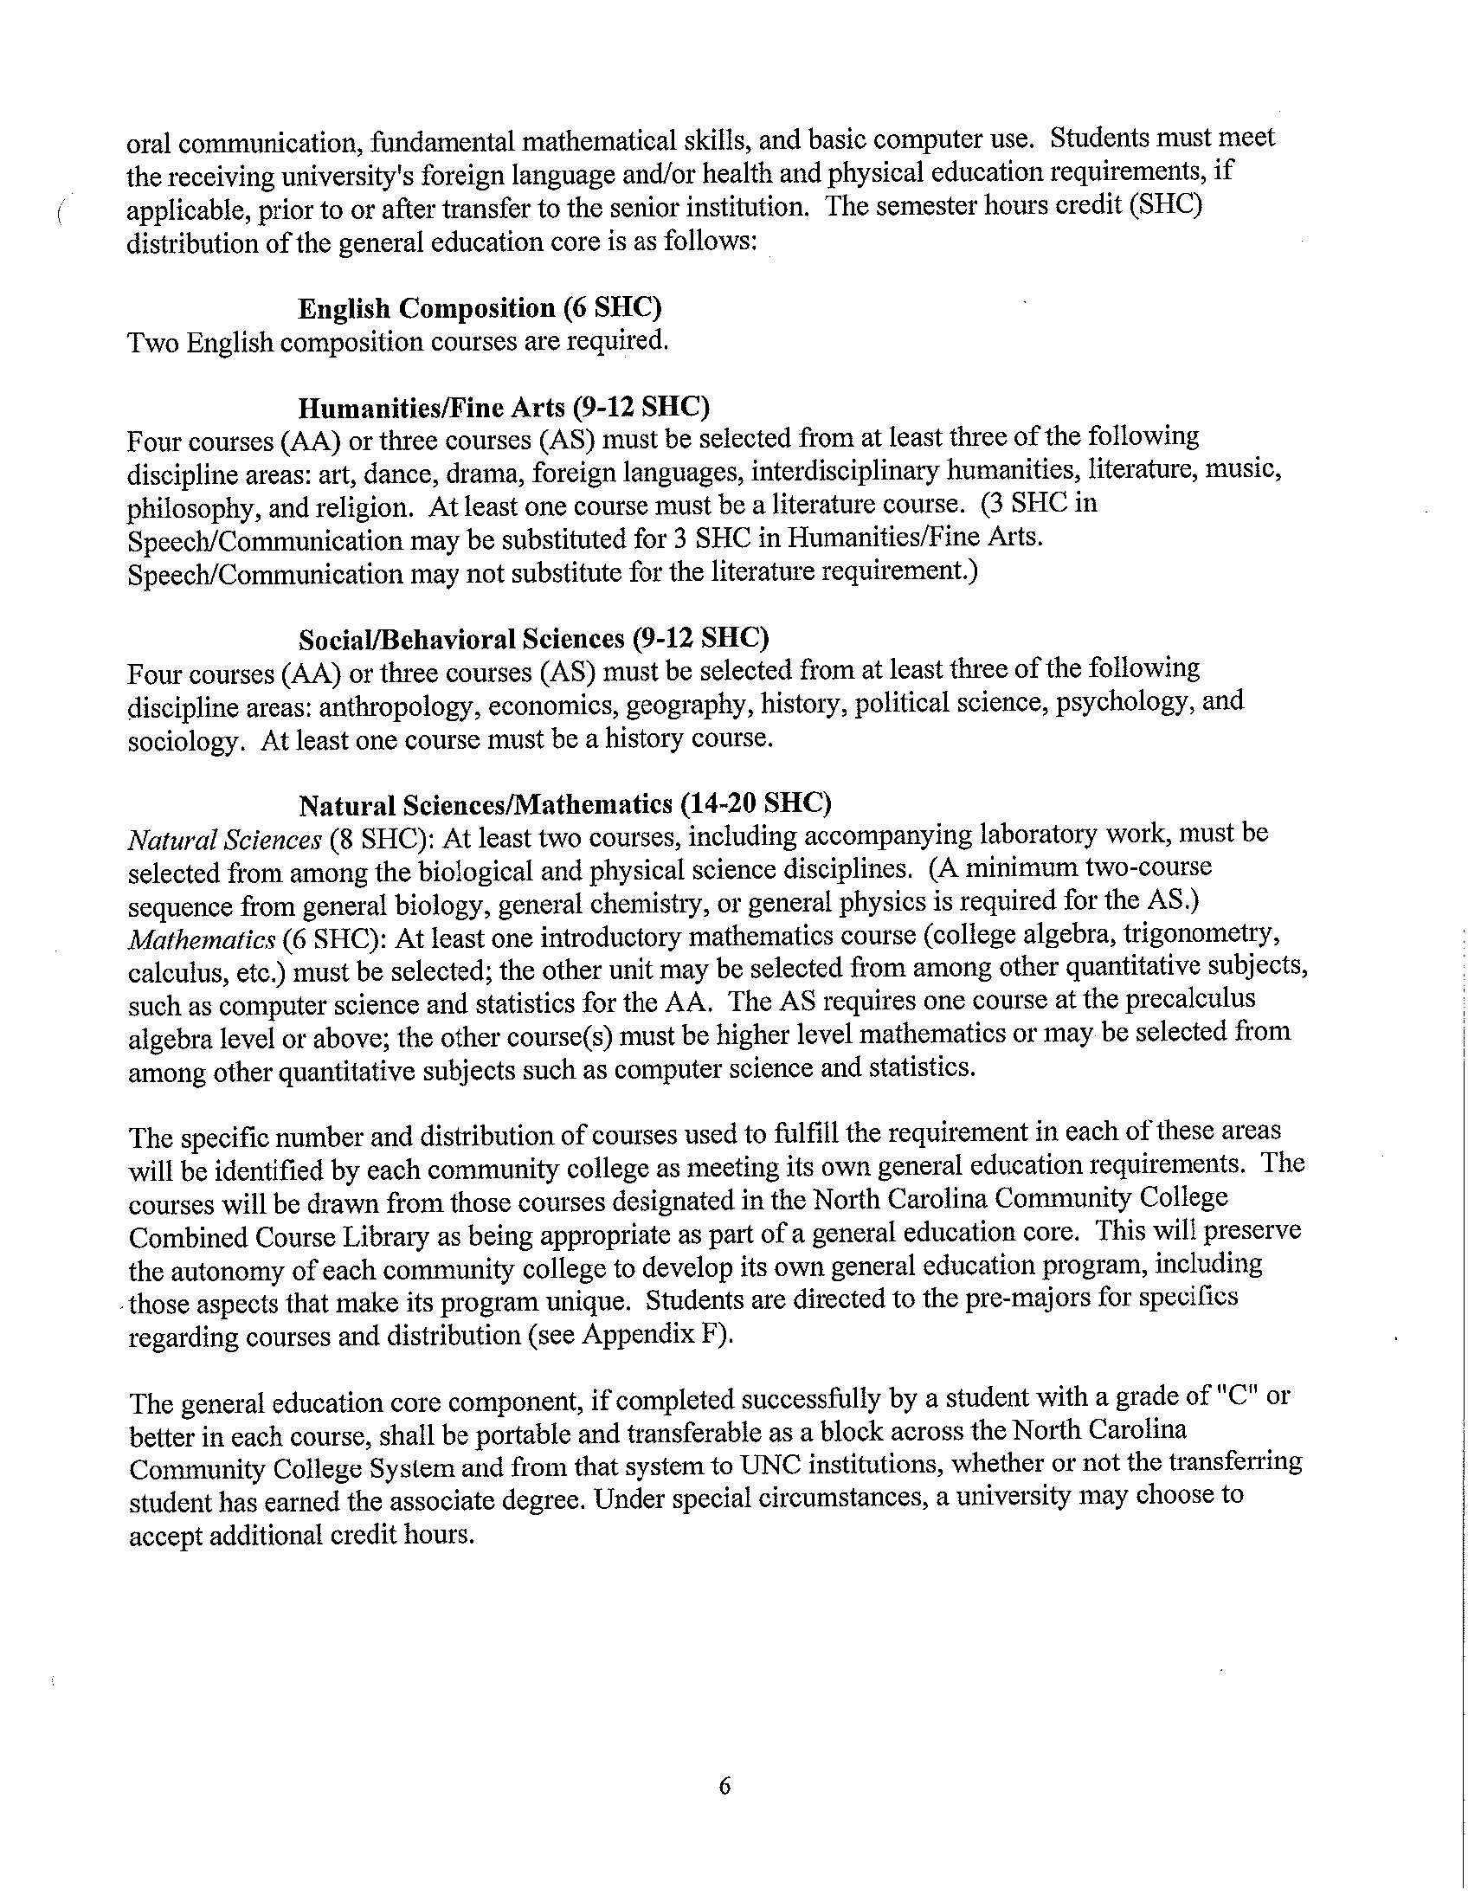

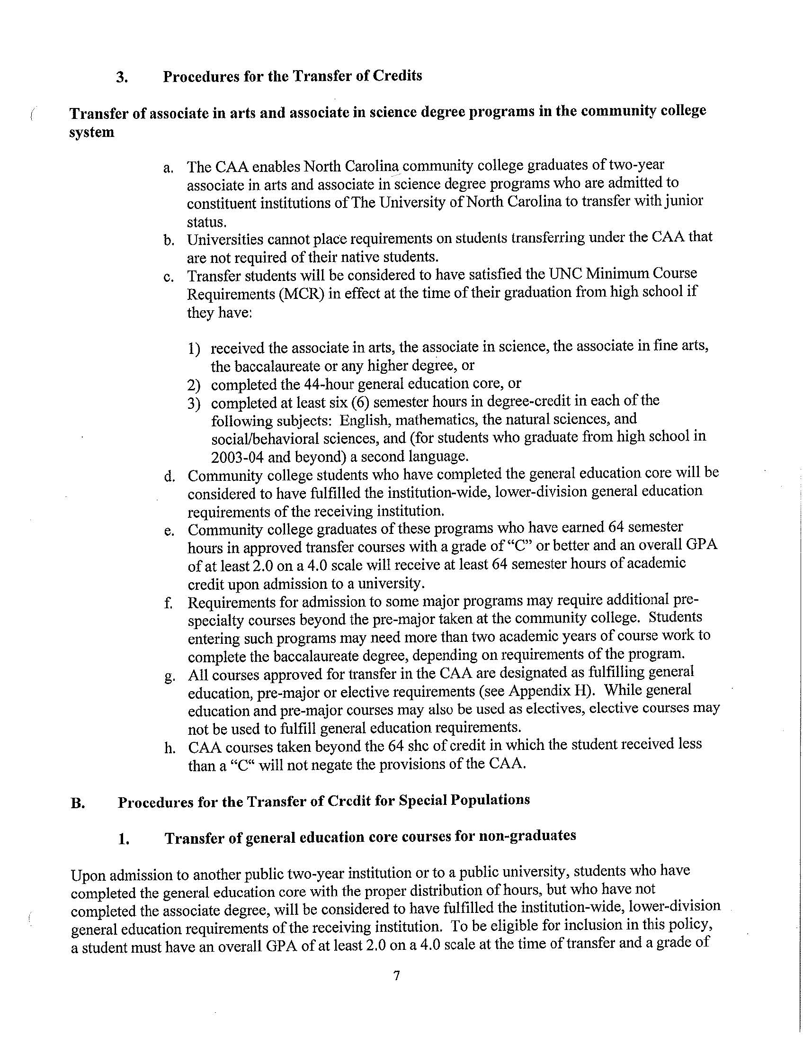

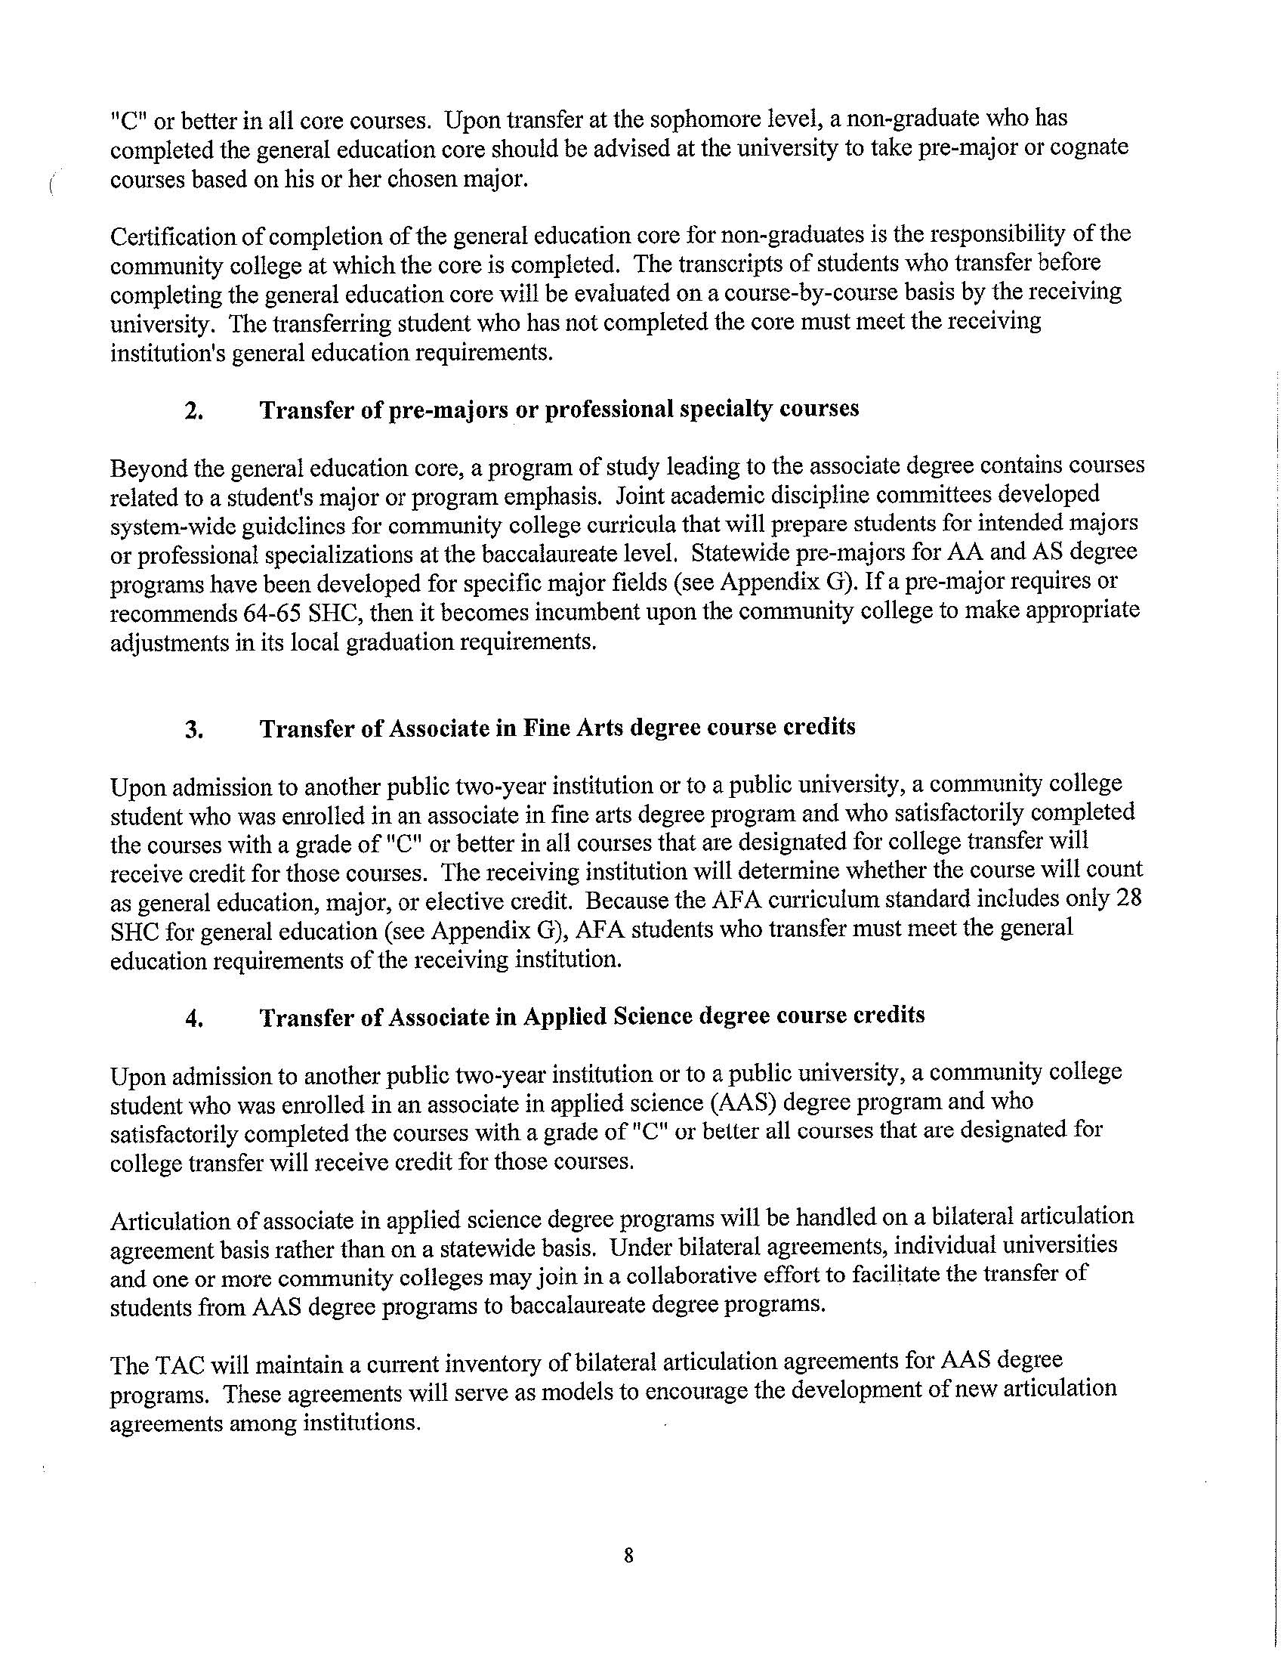

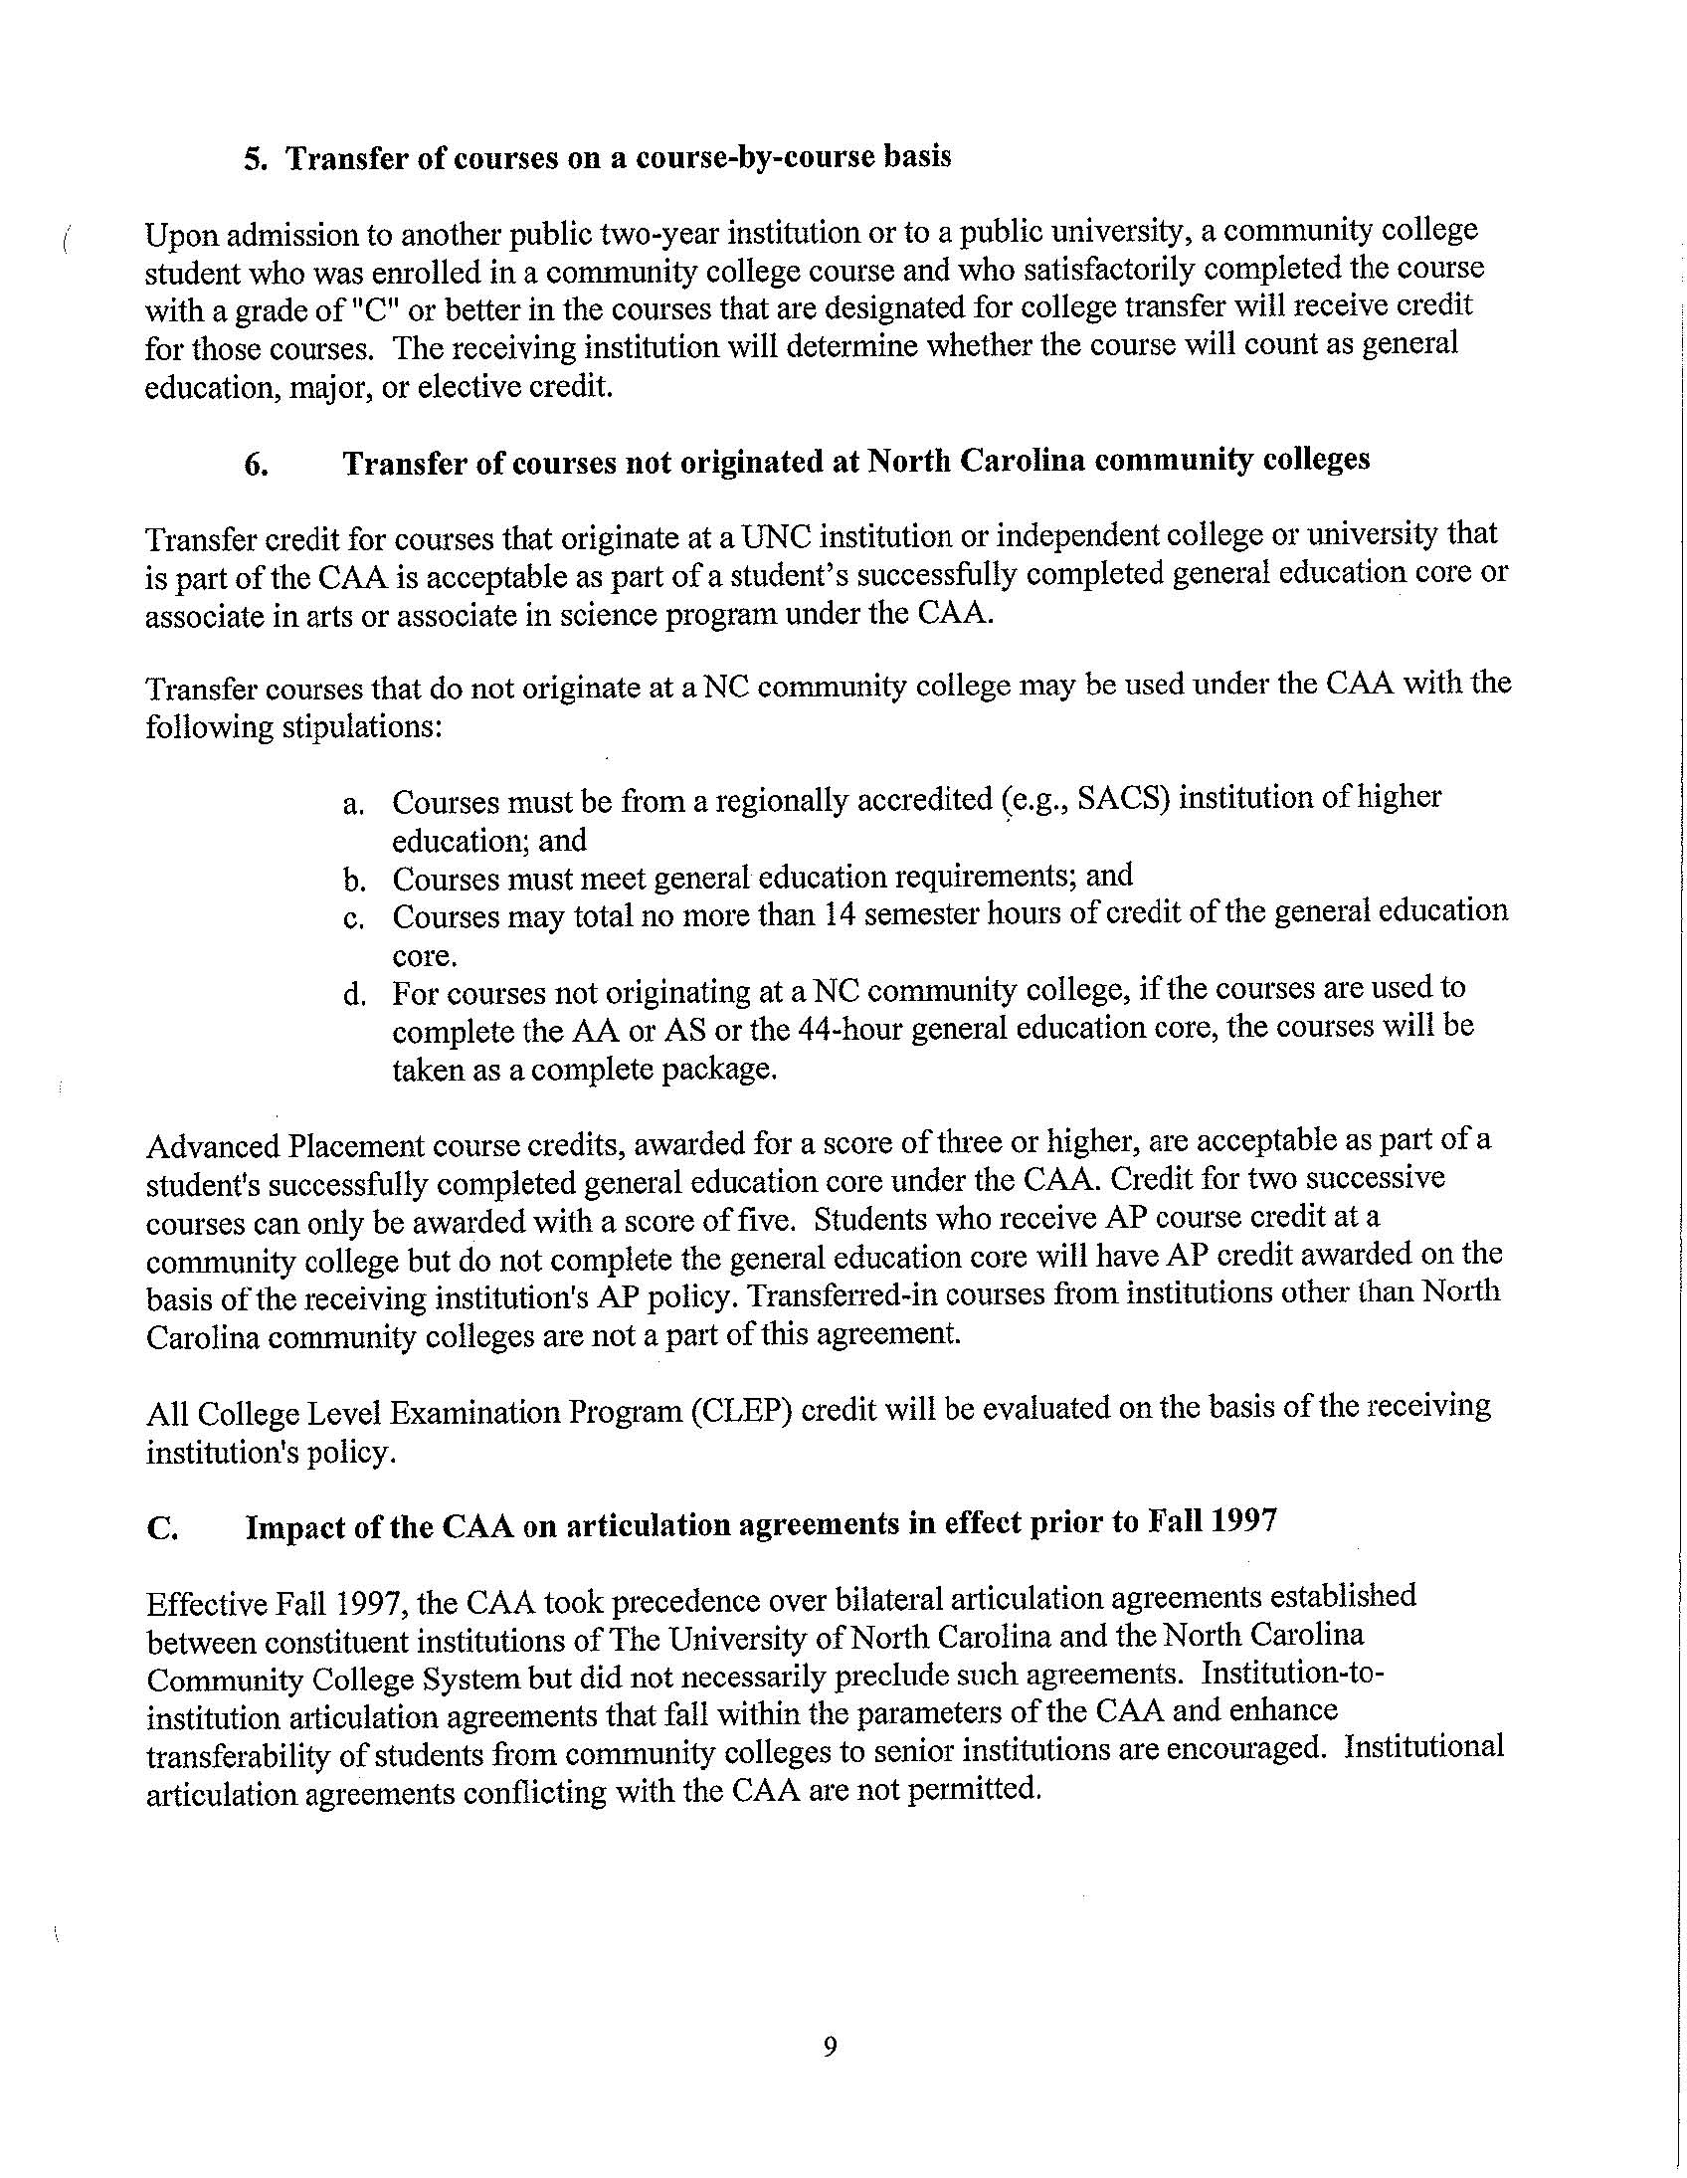
Appendix 3
Comparison of Goals for General Education

ASU and Community Colleges

Comparison of Goals for General Education

ASU and Community Colleges

ASU | WPCC | WCC | CCCT&I | CVCC | SCC
Communicating Effectively | - Communication Skills  - Interpersonal Skills & Human Relations | - Written Communication  - Oral Communication | - Communication skills: written & oral | - Communication | - Communication Skills (writing, reading, speaking)
Thinking Critically & Creatively | - Critical Thinking  - Information Retrieval and Technology  - Quantitative & Qualitative Reasoning | - Mathematics Skills  - Critical Thinking | - Think logically and solve problems using analysis, synthesis, and evaluation  - Apply computational skills | - Mathematics  - Arts & Humanities  - Natural Science | - Critical Thinking Skills  - Quantitative Literacy Skills
Making Local to Global Connections | - Understanding Culture & Society | - Humanities & Social Sciences Awareness | - Recognize & articulate an understanding of global perspectives & cultural diversity | - Social & Behavioral Sciences  - Foreign Language
Understanding Responsibilities of Community Membership | - Interpersonal Skills & Human Relations | - Humanities & Social Sciences Awareness | - Recognize & articulate an understanding of global perspectives & cultural diversity | - Arts & Humanities
 | - Wellness | - Basic Computer Skills; | - Information technology skills: accessing & evaluating information & communicating using technology |  | - Information Literacy Skills  - Technology Skills

Appendix 4
Community College Core Courses
and
ASU General Education Course Equivalents

NC COMMUNITY COLLEGE GENERAL EDUCATION CORE COURSES
AND
APPALACHIAN STATE UNIVERSITY GENERAL EDUCATION MODEL

NC CC  COURSE | 1ST YR  SEM | 1ST YR WRIT | SOPH. WRIT | QUAN.  LIT | AES-  THETIC | HIS/SOC | LOCAL/  GLOBAL | SCIENCE  INQUIRY | INFO COMM TECH LIT | HIS  STUDIES | LITERARY STUDIES | FINE  ARTS | WELL-NESS LIT
ACA 122
ANT 210 |  |  |  |  |  | X | X
ANT 220 |  |  |  |  |  | X | X
ANT 221 |  |  |  |  |  | X | X
ANT 230/230A |  |  |  |  |  | X | X |  |  | X
ANT 240 |  |  |  |  |  | X | X |  |  | X
ART 111 |  |  |  |  | X |  |  |  |  |  |  | X
ART 114 |  |  |  |  | X | X |  |  |  |  |  | X
ART 115 |  |  |  |  | X | X |  |  |  |  |  | X
ART 116 |  |  |  |  | X | X |  |  |  |  |  | X
ART 117 |  |  |  |  | X | X |  |  |  |  |  | X
ASL 111 |  |  |  |  |  |  | X
ASL 112 |  |  |  |  |  |  | X
ASL 211 |  |  |  |  |  |  | X
ASL 212 |  |  |  |  |  |  | X
AST 111/111A |  |  |  |  |  |  |  | X
AST 151/151A |  |  |  |  |  |  |  | X
AST 152/152A |  |  |  |  |  |  |  | X
BIO 110 |  |  |  |  |  |  |  | X
BIO 111 |  |  |  |  |  |  |  | X
BIO 112 |  |  |  |  |  |  |  | X
BIO 120 |  |  |  |  |  |  |  | X
BIO 130 |  |  |  |  |  |  |  | X
BIO 140/140A |  |  |  |  |  | X | X | X
CHI 111 |  |  |  |  |  |  | X
NC CC  COURSE | 1ST YR  SEM | 1ST YR WRIT | SOPH. WRIT | QUAN.  LIT | AES-  THETIC | HIS/SOC | LOCAL/  GLOBAL | SCIENCE  INQUIRY | INFO COMM TECH LIT | HIS  STUDIES | LITERARY STUDIES | FINE  ARTS | WELL-NESS LIT
CHI 112 |  |  |  |  |  |  | X
CHI 211 |  |  |  |  | X |  | X
CHI 212 |  |  |  |  | X |  | X
CHM 131/131A |  |  |  |  |  |  |  | X
CHM 132 |  |  |  |  |  |  |  | X
CHM 135 |  |  |  |  |  |  |  | X
CHM 136 |  |  |  |  |  |  |  | X
CHM 151 |  |  |  |  |  |  |  | X
CHM 152 |  |  |  |  |  |  |  | X
CIS 110 |  |  |  |  |  |  |  |  | X
CIS 115 |  |  |  | X |  |  |  |  | X
COM 110 | C |  |  |  |  | X
COM 120 | C |  |  |  |  | X
COM 231 | C |  |  |  |  | X
DAN 110 |  |  |  |  | X |  |  |  |  |  |  | X
DAN 211 |  |  |  |  | X | X |  |  |  |  |  | X
DAN 212 |  |  |  |  | X | X |  |  |  |  |  | X
DRA 111 |  |  |  |  | X |  |  |  |  |  |  | X
DRA 112 |  |  |  |  | X | X |  |  |  |  |  | X
DRA 115 |  |  |  |  | X |  |  |  |  |  |  | X
DRA 122 |  |  |  |  | X |  |  |  |  |  |  | X
DRA 126 |  |  |  |  | X |  |  |  |  |  |  | X
DRA 211 |  |  |  |  | X | X |  |  |  |  |  | X
DRA 212 |  |  |  |  | X | X |  |  |  |  |  | X
ECO 151 |  |  |  |  |  | X | X
ECO 251 |  |  |  |  |  | X | X
ECO 252 |  |  |  |  | C | X | X
ENG 111/111A |  | X
ENG 112 |  |  | X
NC CC  COURSE | 1ST YR  SEM | 1ST YR WRIT | SOPH. WRIT | QUAN.  LIT | AES-  THETIC | HIS/SOC | LOCAL/  GLOBAL | SCIENCE  INQUIRY | INFO COMM TECH LIT | HIS  STUDIES | LITERARY STUDIES | FINE  ARTS | WELL-NESS LIT
ENG 113 |  |  | X
ENG 114 |  |  | C |  |  |  |  |  | X
ENG 131 |  |  |  |  | X
ENG 231 |  |  |  |  | X |  |  |  |  |  | X
ENG 232 |  |  |  |  | X |  |  |  |  |  | X
ENG 233 |  |  |  |  | X |  |  |  |  |  | X
ENG 234 |  |  |  |  | X |  |  |  |  |  | X
ENG 241 |  |  |  |  | X |  |  |  |  |  | X
ENG 242 |  |  |  |  | X |  |  |  |  |  | X
ENG 243 |  |  |  |  | X |  |  |  |  |  | X
ENG 251 |  |  |  |  | X |  |  |  |  |  | X
ENG 252 |  |  |  |  | X |  |  |  |  |  | X
ENG 261 |  |  |  |  | X |  |  |  |  |  | X
ENG 262 |  |  |  |  | X |  |  |  |  |  | X
FRE 111 |  |  |  |  |  |  | X
FRE 112 |  |  |  |  |  |  | X
FRE 211 |  |  |  |  |  |  | X
FRE 212 |  |  |  |  |  |  | X
GEL 111 |  |  |  |  |  |  |  | X
GEL 113 |  |  |  |  |  |  |  | X
GEL 120 |  |  |  |  |  |  |  | X
GEL 230 |  |  |  |  |  |  | X | X
GEO 111 |  |  |  |  |  | X | X
GEO 112 |  |  |  |  |  | X | X
GEO 113 |  |  |  |  |  | X
GEO 130 |  |  |  |  |  | X
GER 111 |  |  |  |  |  |  | X
GER 112 |  |  |  |  |  |  | X
GER 211 |  |  |  |  |  |  | X
GER 212 |  |  |  |  |  |  | X
HIS 111 |  |  |  |  |  | X | X |  |  | X
HIS 112 |  |  |  |  |  | X | X |  |  | X
HIS 114 |  |  |  |  |  | X | X |  |  | X
NC CC  COURSE | 1ST YR  SEM | 1ST YR WRIT | SOPH. WRIT | QUAN.  LIT | AES-  THETIC | HIS/SOC | LOCAL/  GLOBAL | SCIENCE  INQUIRY | INFO COMM TECH LIT | HIS  STUDIES | LITERARY STUDIES | FINE  ARTS | WELL-NESS LIT
HIS 115 |  |  |  |  |  | X | X |  |  | X
HIS 121 |  |  |  |  |  | X |  |  |  | X
HIS 122 |  |  |  |  |  | X |  |  |  | X
HIS 131 |  |  |  |  |  | X |  |  |  | X
HIS 132 |  |  |  |  |  | X |  |  |  | X
HUM 110 |  |  |  |  |  | X
HUM 115 | C |  |  |  |  | X
HUM 120 |  |  |  |  |  | X | X
HUM 121 |  |  |  |  |  | X
HUM 122 |  |  |  |  |  | X
HUM 130 |  |  |  |  | X | X | X
HUM 150 |  |  |  |  |  | X |  |  |  | X | X
HUM 160 |  |  |  |  | X | X
HUM 161 |  |  |  |  | X | X
HUM 211 |  |  |  |  | X | X
HUM 212 |  |  |  |  | X | X
HUM 220 | X |  |  |  | X | X
ITA 111 |  |  |  |  |  |  | X
ITA 112 |  |  |  |  |  |  | X
ITA 211 |  |  |  |  |  |  | X
ITA 212 |  |  |  |  |  |  | X
JPN 111 |  |  |  |  |  |  | X
JPN 112 |  |  |  |  |  |  | X
JPN 211 |  |  |  |  |  |  | X
JPN 212 |  |  |  |  |  |  | X
LAT 111 |  |  |  |  |  |  | X
LAT 112 |  |  |  |  |  |  | X
LAT 141 |  |  |  |  |  | X
LAT 142 |  |  |  |  |  | X |  |  |  |  | X
LAT 211 |  |  |  |  |  |  | X
LAT 212 |  |  |  |  |  |  | X
LAT 231 |  |  |  |  |  | X |  |  |  |  | X
LAT 232 |  |  |  |  | C | X |  |  |  |  | X
NC CC  COURSE | 1ST YR  SEM | 1ST YR WRIT | SOPH. WRIT | QUAN.  LIT | AES-  THETIC | HIS/SOC | LOCAL/  GLOBAL | SCIENCE  INQUIRY | INFO COMM TECH LIT | HIS  STUDIES | LITERARY STUDIES | FINE  ARTS | WELL-NESS LIT
MAT 140 |  |  |  | X
MAT 141 |  |  |  | X
MAT 142 |  |  |  | X
MAT 151 |  |  |  | X |  |  |  |  | C
MAT 155 |  |  |  | X |  |  |  |  | C
MAT 161 |  |  |  | X
MAT 162 |  |  |  | X
MAT 165 |  |  |  | X
MAT 171 |  |  |  | X
MAT 172 |  |  |  | X
MAT 175 |  |  |  | X
MAT 263 |  |  |  | X
MAT 271 |  |  |  | X
MAT 272 |  |  |  | X
MAT 273 |  |  |  | X
MUS 110 |  |  |  |  | X |  |  |  |  |  |  | X
MUS 112 |  |  |  |  | X |  |  |  |  |  |  | X
MUS 113 |  |  |  |  | X |  |  |  |  |  |  | X
MUS 114 |  |  |  |  | X |  |  |  |  |  |  | X
MUS 115 |  |  |  |  | X |  |  |  |  |  |  | X
MSU 210 |  |  |  |  | X |  |  |  |  |  |  | X
MUS 211 |  |  |  |  | X |  |  |  |  |  |  | X
MUS 212 |  |  |  |  | X |  |  |  |  |  |  | X
MUS 213 |  |  |  |  | X |  |  |  |  |  |  | X
ANY 1 HR PED  ACTIVITY COURSE |  |  |  |  |  |  |  |  |  |  |  |  | X
PED 110 |  |  |  |  |  |  |  |  |  |  |  |  | X
PED 165 |  |  |  |  |  |  |  |  |  |  |  |  | X
PED 172 |  |  |  |  |  |  |  |  |  |  |  |  | X
PED 250 |  |  |  |  |  |  |  |  |  |  |  |  | X
PED 251 |  |  |  |  |  |  |  |  |  |  |  |  | X
PED 252 |  |  |  |  |  |  |  |  |  |  |  |  | X
PED 254 |  |  |  |  |  |  |  |  |  |  |  |  | X
PED 255 |  |  |  |  |  |  |  |  |  |  |  |  | X
NC CC  COURSE | 1ST YR  SEM | 1ST YR WRIT | SOPH. WRIT | QUAN.  LIT | AES-  THETIC | HIS/SOC | LOCAL/  GLOBAL | SCIENCE  INQUIRY | INFO COMM TECH LIT | HIS  STUDIES | LITERARY STUDIES | FINE  ARTS | WELL-NESS LIT
PED 257 |  |  |  |  |  |  |  |  |  |  |  |  | X
PED 259 |  |  |  |  |  |  |  |  |  |  |  |  | X
PED 260 |  |  |  |  |  |  |  |  |  |  |  |  | X
PED 262 |  |  |  |  |  |  |  |  |  |  |  |  | X
PED 270 |  |  |  |  |  |  |  |  |  |  |  |  | X
PED 276 |  |  |  |  |  |  |  |  |  |  |  |  | X
PHI 210 |  |  |  |  |  | X
PHI 215 |  |  |  |  |  | X
PHI 220 |  |  |  |  |  | X
PHI 221 |  |  |  |  |  | X
PHI 230 | C |  |  |  |  | X
PHI 240 | C |  |  |  |  | X | X
PHY 110/110A |  |  |  |  |  |  |  | X
PHY 151 |  |  |  |  |  |  |  | X
PHY 152 |  |  |  |  |  |  |  | X
PHY 251 |  |  |  |  |  |  |  | X
PHY 252 |  |  |  |  |  |  |  | X
POL 110 |  |  |  |  |  | X | X
POL 120 |  |  |  |  |  | X
POL 210 |  |  |  |  |  | X | X
POL 220 |  |  |  |  |  | X | X
POR 111 |  |  |  |  |  |  | X
POR 112 |  |  |  |  |  |  | X
POR 211 |  |  |  |  |  |  | X
POR 212 |  |  |  |  |  |  | X
PSY 150 |  |  |  |  |  | X
PSY 237 |  |  |  |  |  | X
PSY 239 |  |  |  |  |  | X
PSY 241 |  |  |  |  |  | X
PSY 281 |  |  |  |  |  | X
REL 110 |  |  |  |  |  | X | X
REL 111 |  |  |  |  |  | X | X
NC CC  COURSE | 1ST YR  SEM | 1ST YR WRIT | SOPH. WRIT | QUAN.  LIT | AES-  THETIC | HIS/SOC | LOCAL/  GLOBAL | SCIENCE  INQUIRY | INFO COMM TECH LIT | HIS  STUDIES | LITERARY STUDIES | FINE  ARTS | WELL-NESS LIT
REL 112 |  |  |  |  |  | X | X
REL 211 |  |  |  |  |  | X |  |  |  |  | X
REL 212 |  |  |  |  |  | X |  |  |  |  | X
REL 221 |  |  |  |  |  | X
RUS 111 |  |  |  |  |  |  | X
RUS 112 |  |  |  |  |  |  | X
RUS 211 |  |  |  |  |  |  | X
RUS 212 |  |  |  |  |  |  | X
SOC 210 |  |  |  |  |  | X
SOC 213 |  |  |  |  |  | X
SOC 220 |  |  |  |  |  | X | C
SOC 225 |  |  |  |  |  | X | X
SOC 230 |  |  |  |  |  | X | X
SOC 240 |  |  |  |  |  | X
SPA 111 |  |  |  |  |  |  | X
SPA 112 |  |  |  |  |  |  | X
SPA 211 |  |  |  |  |  |  | X
SPA 212 |  |  |  |  |  |  | X

Appendix 5

Proposal for Office of Transfer Articulation

Office of Transfer Articulation

- The Office of Transfer Articulation will be housed within University College.

- The Office of Transfer Articulation will consist of a Director, an Assistant Director, and five staff members. The Director will report to the Executive Director of Academic Advising and Orientation.

- The Office of Transfer Articulation will work closely with the Office of Admissions, the Registrar’s Office, the University College Orientation and Academic Advising Center, the General Education Program, Academic Services for Student Athletes, the Office of Extension and Distance Education, as well as other campus academic units.

- The Office of Transfer Articulation will complete all formal evaluations of main campus applicants’ transfer work. Admitted students will receive a formal evaluation of transfer work along with his/her notification of acceptance to Appalachian. The Office of Admissions will continue to recruit new students and make all admission decisions. Admission decisions will be based on a preliminary review of the applicant’s transcripts by the Admissions Office.

- The Office of Transfer Articulation, working in conjunction with the Registrar’s Office, will create and maintain a transfer equivalency data base within the Banner system. The data base, accessible by anyone on-line, will indicate how courses from other schools may equate to Appalachian State University courses. This data base should be helpful for potential students seeking information about transfer to Appalachian, as well as current students interested in taking a course or two at another institution over the summer.

- The Director and the Assistant Director of the Office of Transfer Articulation will offer advising services for potential transfer students on topics such as appropriate courses to complete before transferring to Appalachian. Both the Director and the Assistant Director will meet the same qualifications as Academic Advisors within the University College Academic Advising Center, in order to ensure accurate and consistent advising campus wide.

- The Office of Transfer Articulation will be a liaison between students requiring a higher level evaluation of transfer credit and the appropriate department/dean’s office with the authority to re-evaluate the credit. This would include working with the Office of International Education and Development, in the assistance of international transfer students. (In the future, this liaison may also include working with the Director of General Education in the resolution of issues regarding the use of an individual’s transfer credit to fulfill General Education requirements.)

- Other responsibilities of the Office of Transfer Articulation will include evaluating transfer course work that is over ten years old. The Office of Transfer Articulation will also develop and maintain a shared calendar with the Admissions Office, the Registrar’s Office, and the University College Orientation and Academic Advising Center.

– February 22, 2008

